HackerEarth Program 6
Link :- https://www.hackerearth.com/problem/algorithm/prime-numbers/
Successful Submission
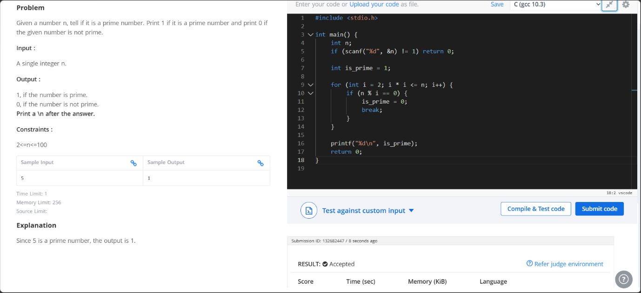
Source Code


